Electronic service “Submission of information for registration of individual / changes to the State Register of Individuals – Taxpayers in electronic form using a qualified electronic signature”

Procedure of forming request
On computer connected to the Internet, using web browser, log in to the payer’s “Electronic Cabinet” at the link: cabinet.tax.gov.ua or on the official web portal of the State Tax Service.
Using a qualified electronic signature, enter to private part of Electronic Cabinet (personal account) as follows:
- select appropriate accredited key certification authority (Accredited Key Certification Center);
- select personal electronic key by choosing appropriate file from the electronic media (USB drive, CD / DVD drive) or in the appropriate directory on a personal PC (Key-6.dat);
- enter security password and click “Read”. After the key is successfully downloaded, click “Login”.
Submission of
Account card №1DR of individual-taxpayer /
Application of changes № 5DR to the State Register
Individuals – Taxpayers
(electronic form F1314601/ F1314701)
In the main menu of personal account in section “EC for citizens” it is needed to select “Account card of individual-taxpayer (1DR)” or “Application for changes to the State Register of Individuals – Taxpayers (5DR)” and click <+Create>
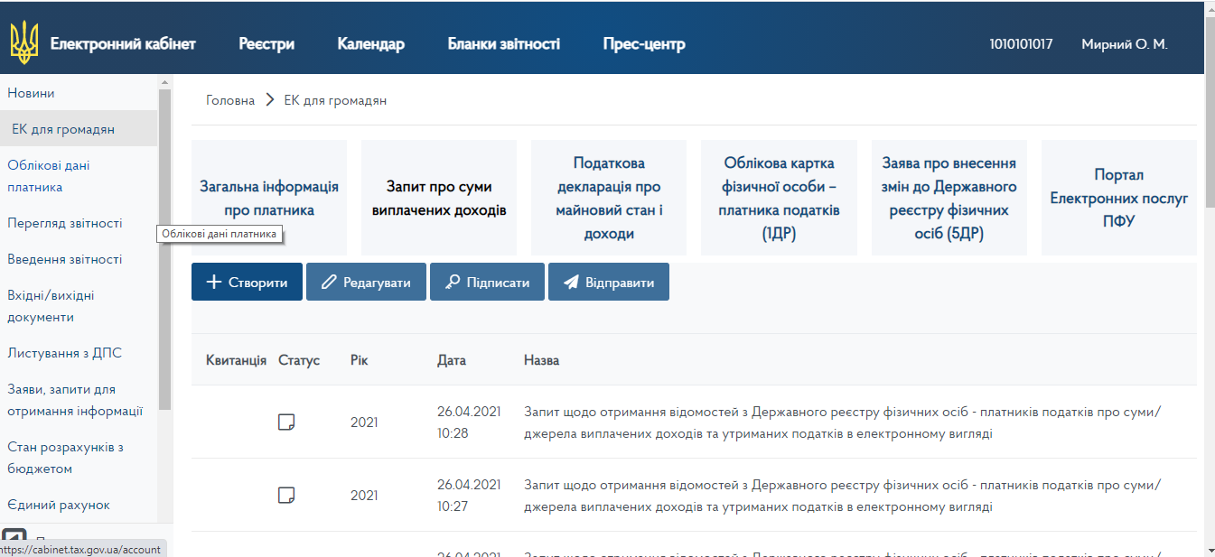

Fill in the Account Card of individual-taxpayer according to the “Reference on filling in the Account Card of individual-taxpayer” / Application for changes to the State Register of Individuals – Taxpayers according to the “Reference on filling in the Application for changes to the State Register of Individuals – Taxpayers”.
Add mandatory annexes to the Taxpayer’s Account Card / Application for changes to the State Register of Taxpayers – Individuals (tab “Annexes”).
In addition, add form F1314501 and read “Notification on the composition and purpose of personal data collection from the State Register of Individuals – Taxpayers, rights and obligations of individuals-taxpayers”:
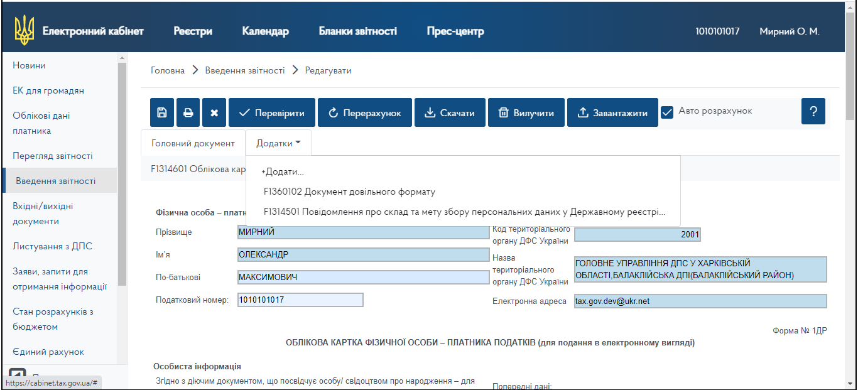

Add form F1360102 – Arbitrary format document used to submit scanned copies of required documents, each document must be saved in a separate attachment (file format can be pdf / jpg with a size limit of not more than 2MB)

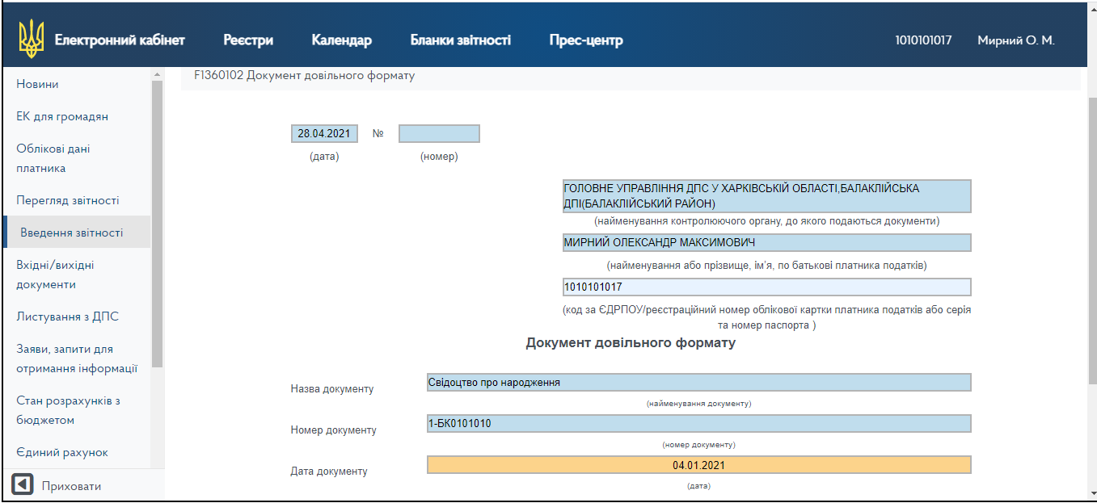
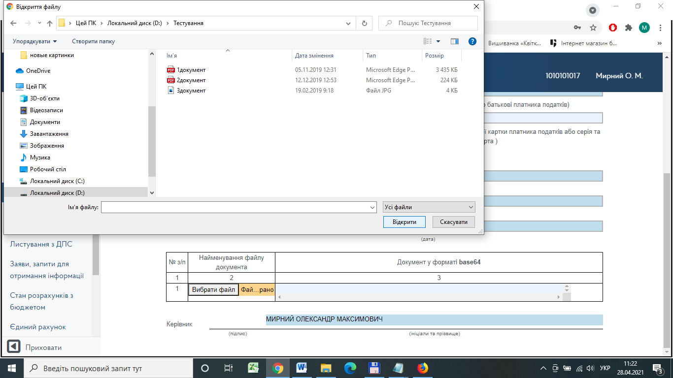

Click the “Check” button. System automatically checks the completeness of fields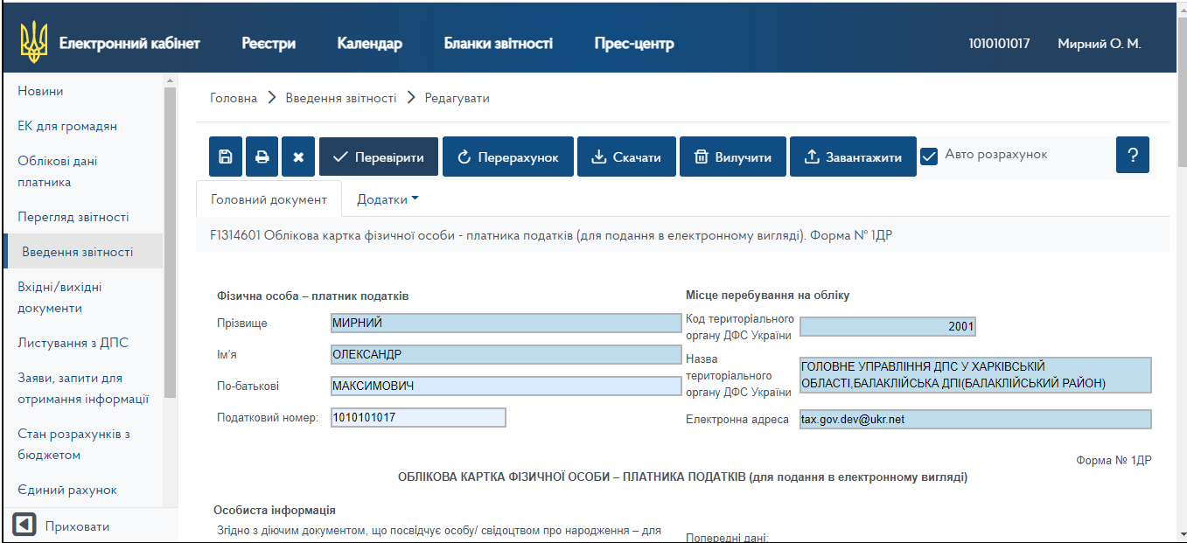
If the check fails, a message is displayed indicating a reason (error) for not being able to create and save the document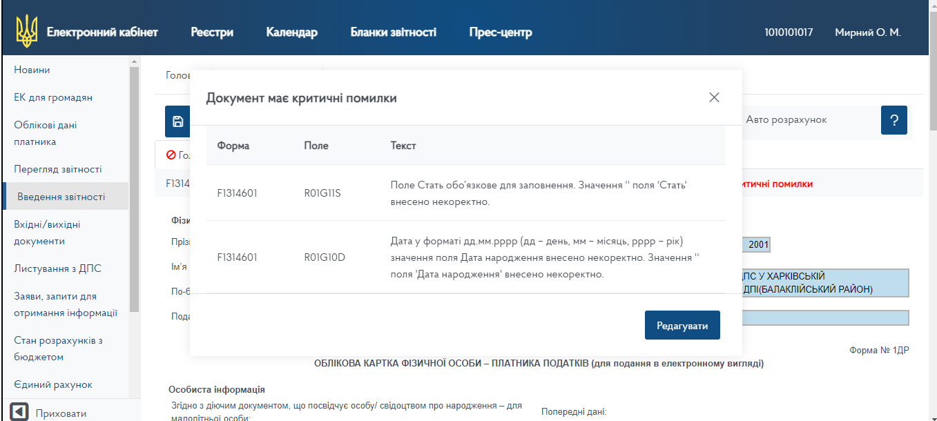
м
або
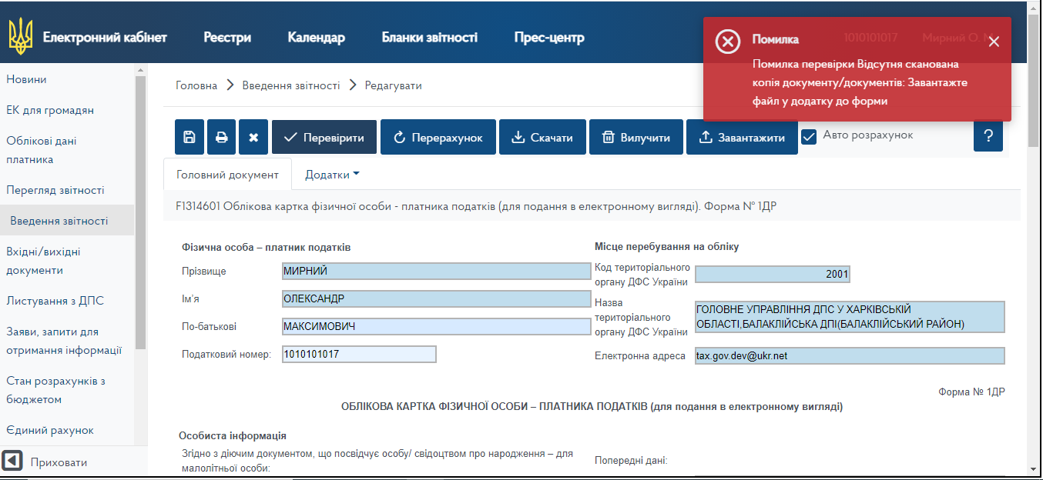

If the check is successful – message “Checked” is displayed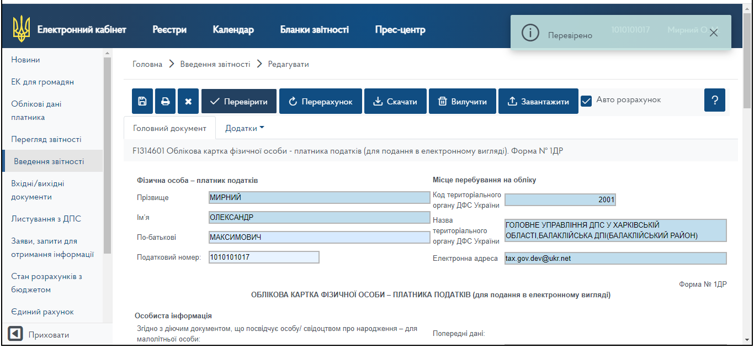
Click “Save”
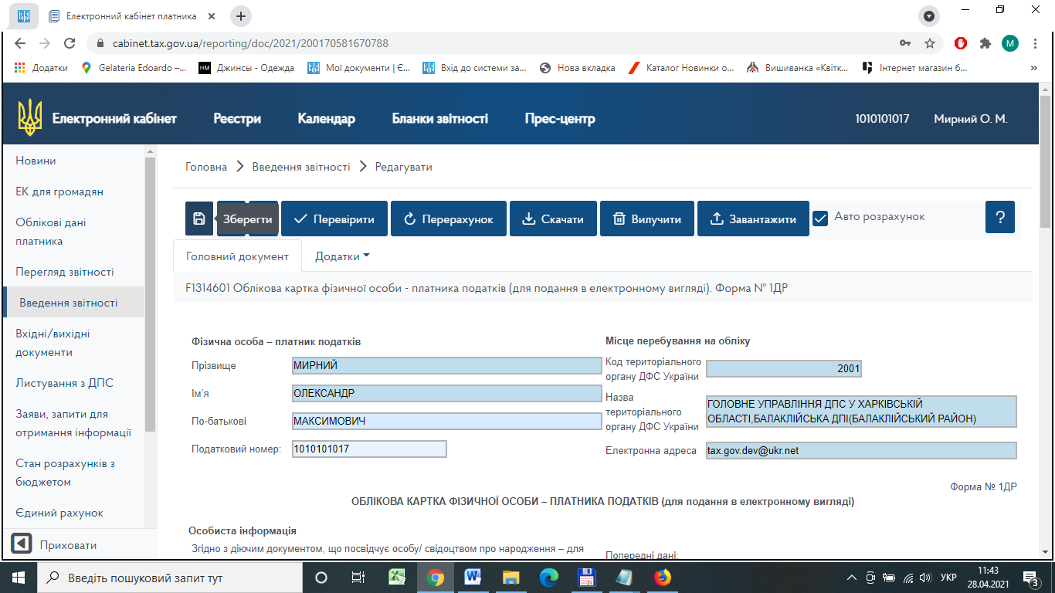
Sign generated request with a qualified electronic signature and send it to the State Tax Service.

The following answer will be sent:
Receipt №1 – Notification of acceptance of request;
Receipt №2 – Notification of the processing results in form F1414601 (for the Account card of individual-taxpayer) / F1414701 (for the Application for changes to the State Register of Individuals – Taxpayers).
